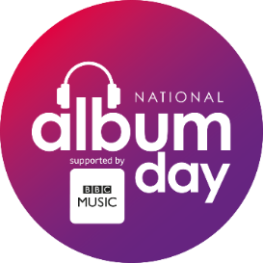

**National Album Day 2019**

**Label Toolkit**

**When:** Saturday 12th October 2019

**What:** National Album Day is organised by the people behind Record Store Day, the Mercury Prize and the BRIT Awards. It’s a celebration of the art of the album, championing not only its iconic heritage but engaging a new generation of music lovers to the joys of the album as a body of work. Hundreds of physical retailers and DSPs are celebrating the event with in-store activities and bespoke online campaigns.

**Don’t Skip** is the theme behind 2019 tying together the editorial, retail and social elements of the campaign. It explores the benefits of taking time out to listen to an album from start to finish and the ways this can significantly improve wellbeing and mindfulness. Not limited to chillout or relaxation genres – simply letting your favourite albums be the antidote to the fast-paced and hectic lifestyle of the modern world!

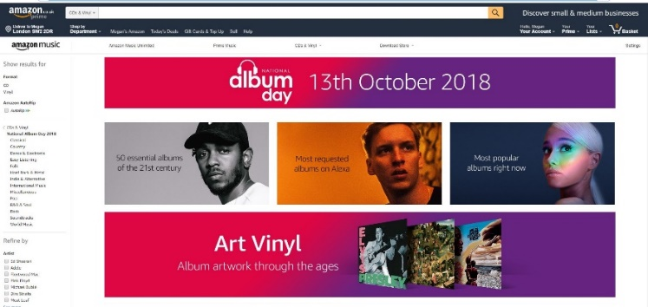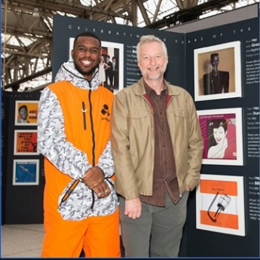**BBC Sounds** are our official media partner once again and are coordinating a week’s worth of album focussed programming across TV, radio, socials and online news. 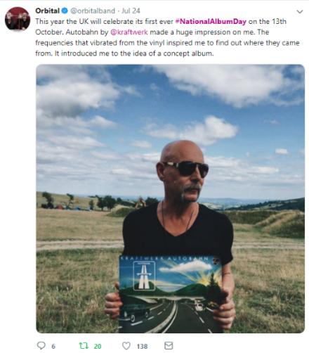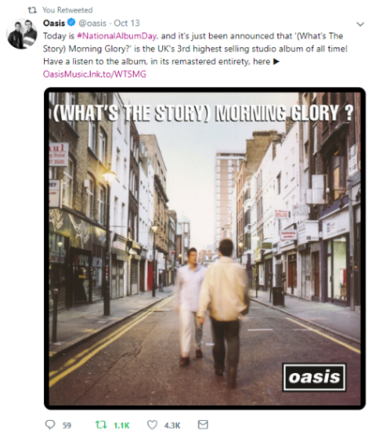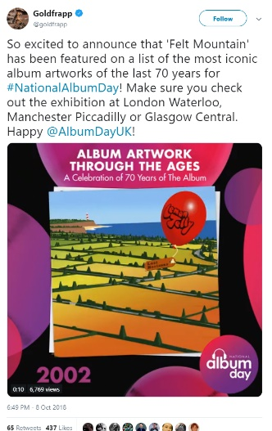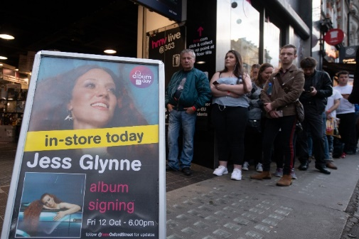

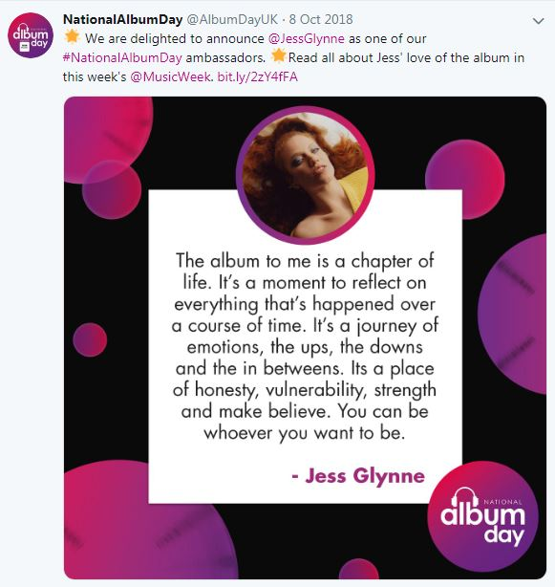**How to get involved?**

**Digital:** To join us in sharing the album love on socials we are asking artists to deliver the following content and to post across their accounts using #DontSkip and #NationalAlbumDay

Please answer these **TWO** questions:

* *I #dontskip a single track on [album] by [artist] because…*
* *What does the ‘album’ mean to you?*

We also have a selection of other questions to help highlight your artist’s love of the album. Feel free to answer as many or as little as you’d like:

* 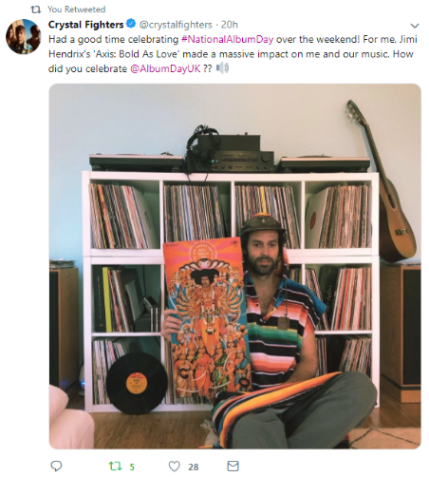What’s the first album you bought?
* What’s the last album you listened to?
* What album inspired you to get into music?
* What album do you wish you had released?
* Which one of the albums you’ve released/worked on are you most proud of?
* What’s your favourite album of the year so far?
* What album reminds you of your childhood?
* What album did you first fall in love to?
* What album always makes you smile?
* What album do you listen to after a bad day?
* What album do you think has the most important message that everyone should hear?

Formats

1) Delivered as a video message under 1 min for use across artist and @AlbumDayUK socials  
2) Delivered as an image of artist holding said album alongside quote for use across artist and @AlbumDayUK socials  
3) Delivered as text to be used as quotes across artists and @AlbumDayUK platforms.

Please send all digital submissions/assets to [darren.kruse@bpi.co.uk](mailto:darren.kruse@bpi.co.uk) & [phoebe@eraltd.org](mailto:phoebe@eraltd.org)

**Press & PR**: We are looking to recruit a diverse range of artists to share their love of the album across media, press and broadcast. Please urgently advise [casandra.strauss@bpi.co.uk](mailto:casandra.strauss@bpi.co.uk) and [megan@eraltd.org](mailto:megan@eraltd.org) which artists you have in cycle and can be available for interviews, providing quotes and other media content etc.

To pitch an idea as part of official BBC Sounds coverage please send details and artist availability to [casandra.strauss@bpi.co.uk](mailto:casandra.strauss@bpi.co.uk) & [megan@eraltd.org](mailto:megan@eraltd.org) ie

* Album releases: Artists releasing albums in October 2019 who would like to be put forward for editorial/ guest slots w/c 7th October should let us know as soon as possible
* Story-telling: BBC want to hear the best album related moments, unheard stories from artists, interesting facts for fans, key anniversaries etc to bring our love of the album to life.

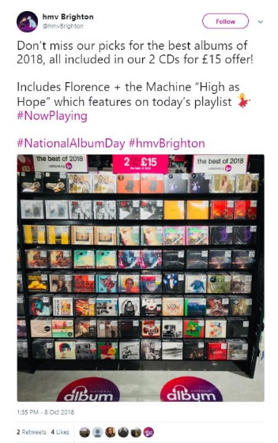**Retail:** Hundreds of physical retailers and DSPs are promoting the campaign in-store and online.

* We encourage labels to engage with retail partners about bespoke in-store and online promotions
* Deliver retail specific messages from artists with albums in promo ie *‘You can listen to/ pick up a copy of my album XXXX this National Album Day on/ at XXXXX. It was heavily inspired by XXXXX which is one of my most loved records of all time.*
* Provide money can’t buy prizes for retailers ie gift with purchase, UK-wide treasure hunt for unique prizes, gig tickets hidden in albums, signed copies for social giveaways etc
* In-stores (see events)
* Labels may also want to consider an album release on 11th Oct to enjoy the additional album related PR

**Events:** A hugely important part of celebrating NAD will be through putting on events. We will be promoting these events on the NAD website, socials and in an event press release in the run up to NAD, with a keen focus on w/c Oct 7th and even more so, Oct 12th.

***Types of events you may wish to consider:***

* Album Playbacks
* Gigs
* In Conversations: We have once again partnered with Classic Album Sundays for a week of activities. If you wish to take part, please email [casandra.strauss@bpi.co.uk](mailto:casandra.strauss@bpi.co.uk) for an introduction. In Conversations don’t need to be limited to this setup though – think creatively! Is there a younger artist who could have a discussion with a heritage artist about the albums that inspired them? Is there a local record shop or iconic venue who can host this?
* In-stores and Signings: anything from short live performances – to longer sets, through to signings and meet & greets in independent record shops and HMVs up and down the UK
* Online: live streaming of an album in full, Q&As/ AMAs focused around an artist’s seminal album, etc
* Fun and Culture: anything else that’s exciting for fans, that doesn’t fall in these categories
* *Secret Stunts* Please think of interesting stunts your artists could do – such as serving customers in record shops, making surprise appearances/ performances, etc. We would advise reserving this for Oct 12, the actual NAD day – as press & the BBC will be looking for exciting events/ destinations to cover.

***How we can amplify this:***

Do let us know as far in advance as possible what you’re planning. For public events, please upload the relevant information through the form available on the website: <https://www.nationalalbumday.co.uk/get-involved/>. For more complex requests/ secret stunts, email [casandra.strauss@bpi.co.uk](mailto:casandra.strauss@bpi.co.uk)

Here’s what we’ll do:

* We’ll provide digital assets so you can badge up your announcements and even print banners or other physical assets for the day itself
* We’ll publish the details in the Events section of the website – which will become the central hub of activity. People will be able to filter these activities by type, location, etc.
* We’ll liaise with our PR agency to flag exciting opportunities for press to cover
* We’ll liaise with the BBC, who could send reporters to cover the events. Regional activity is possible – so any event, big or small, outside of London, will be extremely welcome.